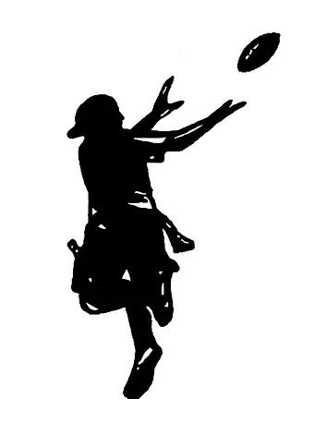

Youth Flag Football League
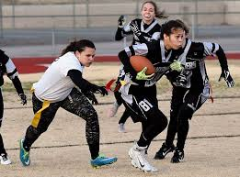
Mill Creek MetroParks proudly presents the first NFL Flag Football League for 4U, 6U, 8U, 10U, and 12U divisions. Player evaluations and last day of registration is April 11th. Season starts on May 14th and every team will play 6 regular season games with a single elimination tournament to follow. Every player will receive a Jersey, flags with belt, socks, shorts, drawstring bag, and a water bottle.

Participant Name: ____________________________________________________Birth Date__________________ Address: __________________________________________________________City: ________________________ Zip: ________________________________County: ____________________________________________________
Email: ___________________________________________Phone Number: ________________________________
Age: __________ Male/Female: __________ Shirt Size (Circle): YS YM YL AS AM AL
***Attention participants*** Please read the following and each participant must print and sign their name below. “The undersigned recognizes that there are potential risks associated with the game of flag football and that there is a potential for injury, including but not limited to injuries resulting from physical strain, errant shots, or kicks. As with any exercise or physical activity, you should consult your physician before beginning a new activity. The undersigned hereby releases Mill Creek MetroParks and its employees, agents, or affiliates from any liability with respect to any injury or loss sustained by the undersigned during any activity on Mill Creek MetroParks premises.”

MCMP reserves the right to use photos and videos at its discretion for media coverage and promotional materials, including broadcasts, reports, publications, and marketing materials of MCMP. If you do not wish to be photographed or video recorded, please let the photographer know before being photographed/videotaped. MCMP otherwise assumes that it has your permission to photograph or video you and/or your child’s involvement in this activity.

Parent / Legal Guardian

Print: ____________________________________Sign: _____________________________________Date: __________

Are you willing to be a coach? (Circle): Yes or No If Yes, Print Name: ________________________________

Coach Shirt size (Circle): AS AM AL XL XXL
Program Fees: $119.99 R, $129.99 NR
Cash, MasterCard, Visa, Discover, Checks Accepted
(Please make all checks payable to: Mill Creek Wick Recreation)
**No refunds will be issued after 4/11/2022**

Scan and email completed form to: cbundy@millcreekmetroparks.org

Online Registration at: https://reservations.millcreekmetroparks.org/internal/programs/905/

Call Wick Recreation Area with any questions: 330.740.7114

